Title of the Paper (Times New Roman, size 16, Bold, spacing 1.5)

Author^{*1}, Author², Author³

¹Affiliation Email: abcdefg@gmail.com

² Affiliation Email: abcdefg@gmail.com

³ Affiliation Email: abcdefg@gmail.com

Summary: (Times New Roman, Size 12, right justified) Designing a deep neural network for multiclass classification has been a challenging task in comparison to binary classification. In this paper, a very deep learning model for dorsal hand vein recognition is presented. Deep learning models may contain hundreds of hidden layers. The increase in layers makes a model complex and it takes much time to train especially on CPU instead of GPU. The proposed model consists of network of Convolution layers and ReLU layers followed by one Global Average Pooling layer and two dense layers. To keep the model stable, batch normalization is applied on input and hidden layers and Adam optimizer is used to optimize the model. For the training and testing purpose two self-constructed datasets are used, first having 1200 dorsal hand vein images of children of age ranging from 05 to 12 years and second having 2000 dorsal hand vein images form 100 adults. The accuracy of the proposed model is compared with two recent contributions, which also used self-constructed datasets. The accuracy of the proposed system observed is 98.33% while trained and tested with children' dataset, and 100% while trained and tested with adults' dataset.

Keywords: 4-6 keywords separated by ;

Introduction (Times New Roman, size 16, Bold, spacing 1.5)
(Times New Roman, Size 12, justified) The references to be cited in the text properly^{[1-2]} and palm vein^{[3]}. .....................................................................................................................

Heading 2 (Times New Roman, size 16, Bold, spacing 1.5)
(Times New Roman, Size 12, justified) The references to be cited in the text properly^{[1-2]} and palm vein^{[3]}. .....................................................................................................................

Heading 3 (Times New Roman, size 16, Bold, spacing 1.5)
(Times New Roman, Size 12, justified) The references to be cited in the text properly^{[1-2]} and palm vein^{[3]}. .....................................................................................................................
The figure numbering and caption to be mentioned like belo example.
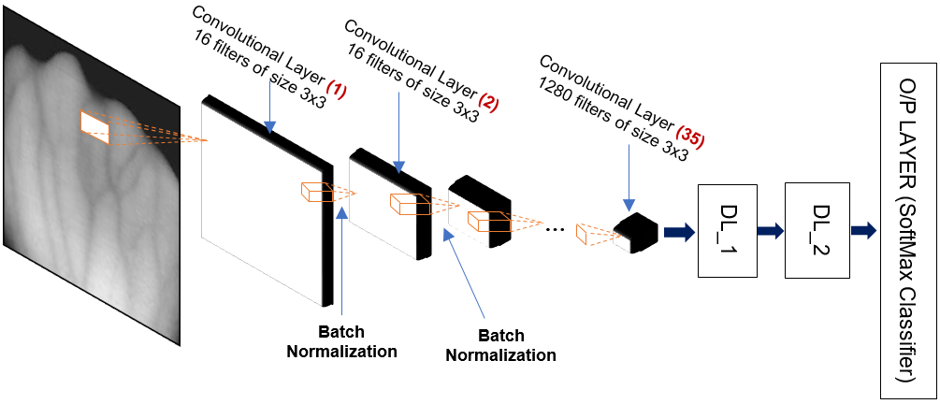
Figure 1(a).
The Architecture of Proposed Deep Learning Model

Heading like Experiments (Times New Roman, size 16, Bold, spacing 1.5)
The detals of practical implementation of model and results to be explained.^{[22]}

Sub-heading
The dense layer is a ........................... .............................. ......................... .................... ............... ................ ................ ...... distortion vector and the activation of the previous layer. The table numbering and caption example is below
Table 1.
The Comparison of proposed system with Rajalakshmi et al.^{[18]} and Janes & Brandao ^{[20]}
 |  | Proposed System |  |  | Rajalakshmi et al. (2018) [18] | Janes & Brandao (2014) [20]
Dataset size |  | 1200 (children) and 2000 (Adults) |  |  | 4030 | 1240
Hardware |  | 8 GB RAM |  |  | 32 GB RAM, 8-core CPU | Unknown
Implemented using |  | Python, Keras, TensorFlow |  |  | Python, Sci-Kit Learn | Matlab
Accuracy | Children | Case (i) | Case (ii) | Case (iii) | 99.30% | 96.85%
 |  | 97.50% | 97.50% | 98.33%
 | Adults | 100%

The equations are to be written using equation editor and to be numbered.
$accuracy= \frac{TP+TN}{TN+FN+FP+TP}$ (1)

Conclusion
The proposed deep learning model is evaluated ............................ ............................. ............... years to observe variation in prediction accuracy.

Acknowledgements
The authors gratefully acknowledge ..................... ........................ ................ for providing necessary help and support to do this research work.
Only the genuine and standard refernces to be used. The refernces and their proper citations in the manuscript will be verified by experts. The references to be provided as per following format
For Science and Technology Track
- O. V. Morozova L. V. Ivanova, Information technologies in state and municipal administration, pp. 224–312 (2018).
- T. V. Romashkin, N. G. Ustinova, Digital Entrepreneurship: Challenges and Development Prospects, pp. 130–134 (2020).
- M. O. Kalinnikov, “Labor market overview” in Information Technology, pp. 125–184 (2019).
- S. I. Gasumova, Information technologies in the social sphere, pp. 63–78 (2020).
- M. P. Kogalovsky, Advanced technologies of information systems, pp. 42–49 (2019).
- N. V. Beresa, Information Services Market: Current Trends and Development Prospects, pp. 78–89 (2020).
- E. A. Mazilov, Problems and prospects for the development of scientific and technological spaces, pp. 59–69 (2018).
- Yu. A. Romanova P. V. Muzychkin S. A. Vokina, Information technology in management, pp. 68–79 (2019).
- E. A. Tanenbaum D. A. Weatherall, Computer Networks 5(2), pp. 85–97 (2019).
- E. A. Aksyutik E. N. Krolivetskiy, Innovative development of sectoral components of the service sector: monograph, pp. 78–82 (2019).

For Material Science and Engineering Track
[1] H. G. Hong, M.B. Lee, K.R. Park, Sensors 2017, 17(6), 1.
[2] K. Shaheed, H. Liu, G. Yang, I. Qureshi, J. Gou, Y. Yin, Information 2018, 9(9), 1.
[3] A. Kumar, K. Wang, DLPR Proc. - The Hong Kong Poly. Univ., Hong Kong 2016, 1
[4] R. Kumar, R. C. Singh, A. K. Sahoo, Int. J. Inno. Tech. Explo. Eng. 2019, 8(10s), 444
[5] B. Belean, M. Streza, S. Crisan, S. Emerich, Studies in Informatics and Control 2017, 26(3), 305.
[6] B. Belean, M. Streza, S. Emerich, Studies in Infor. and Control 2017, 26(3), 305.
[7] K. Ito, Aoki, T., ITE Tran. on Media Tech. Appl. 2018, 6, 64.
[8] A. K. Jain, K. N. Kumar, A. Rossa, Pattern Recog. Letters 2016, 79, 80.
[9] A. Shukla, J. Dhar, C. P. Meena, D. Sharma, R. K. Anand, S. Sharma, presnted in IEEE Int. Conf.: GCIS Xiamen, China (May 2009), 267
[10] A. Krizhevsky, I. Sutskever, G.E. Hinton, Adv. in Neural Info. Proc. Sys. 2012, 1097.

